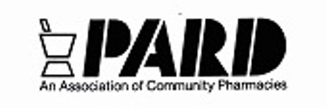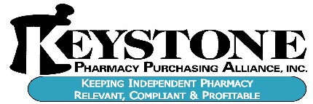
Dear PARD/Keystone Members:
2018 brings with it some very important legislative activity that we have to work hard to accomplish.
- Immunization Legislation-lowering minimum age from 18 to 9 years of age.
- Reimbursement Medicaid changes scheduled to take effect April 2018. We need to be at the discussions!
- PBM Transparency in DIR fee language – Where is this money going?
- Medical Marijuana – Monitor & respond to regulations
- Carve out Pharmacy in Medicaid or mandate MCO’s pay the same as Fee For Service

We have disbursed over $20,000 in 2017 from our PhilPAC account & it needs to be re-vitalized. Your help is crucial!
At present, we have 31 members making monthly donations to PhilPAC via credit card, with 6 more making once-a-year donations. See listing below. If your name is not listed, please consider adding your name; an application is included. Personal credit card or personal check is required to make donations to PhilPAC. Due to state law, we cannot accept corporate checks and they will be returned. For monthly donations, credit card is preferred.

2018 Monthly Contributors:
Mel Brodsky Gary Ng Craig Lehrman Burt Zazlow
Steven Theodorou David Ostrow Loc Dao Jeff Moskowitz
David Cunningham Perry Koffer Brian Walker Vince Canzanese
Joe Ralston Mat Slakoper Frank A. Rubino Charles Lebegern
Stan Goodman Lina Rossi Robert Schreiber Frank R. Rubino
Robert Frankil Brian Snyder Randy Policare Jon Brookland
John Quinn David Stone Michael Levin Brad Tabaac
Joseph & Maria McNeill Walt Cwietniewicz Steven Albertson

2018 Annual Contributors:
Solomon Ogunsola Jane Dzierza Steven Tammara Jim Tehrani
Iyabode Leah Adewale Michael Patton

Your participation would be greatly appreciated. We have made much progress for the future success of Independent pharmacy, but we cannot discontinue our efforts now, and we urgently need your help.

Very truly yours,

Mel Brodsky, R. Ph. Perry Koffer, R. Ph.
Executive Director President
melb@pardrx.com

2200 Michener Street | Suite 10 | Philadelphia, PA 19115 | 215-464-9890 (O) | 215-464-9895 (F) | www.pardrx.com

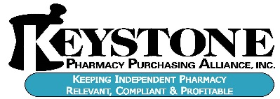

Thank you for your support

Store Name: _________________________________ Your Name: _________________________________
By State law PARD PhilPAC cannot accept corporate checks.

- Enclosed is my personal check made payable to the PARD PhilPAC in the amount of $__________

Home address if not listed on check: _____________________________________________________

- I hereby authorize a monthly debit to my personal credit card in the amount of $______________ as a contribution to the PARD PhilPAC Fund

- I hereby authorize a one-time debit to my personal credit card in the amount of $______________ as a contribution to the PARD PhilPAC Fund

Personal Credit Card Information – VISA, MasterCard, and American Express accepted

Account Number: Expiration Date: Security Code:

_________________________________ ______________ ______________

Name on account: Amount Paid:

__________________________________ _______________

Signature:

_________________________________________________________________________________________

Billing Address of the personal credit card being used including City, State & Zip

2200 Michener Street | Suite 10 | Philadelphia, PA 19115 | 215-464-9890 (O) | 215-464-9895 (F) | www.pardrx.com

